NYAC LAY SPEAKER
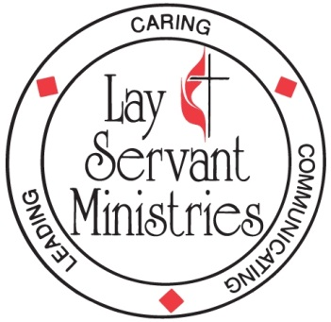
APPLICATION
REQUEST OF THE LAY SERVANT TO
BE CONSIDERED AS A LAY SPEAKER
( )Initial Application or( )Request for Renewal

(Part 1) DATA ON THE CERTIFIED LAY SERVANT
Name (Mrs. ___ Ms. ___ Mr. ___) _________________________________________________
Address ______________________________________________________________________ City/State/ Zip _________________________________________________________________
Telephone (H) _______________________ (Other: W __ C __) __________________________
Name of Church ________________________________ District _________________________
Church Address ____________________________ City/State ___________________________
Church Telephone _______________________________ Zip Code _______________________
(Part 2) STATUS OF CERTIFIED LAY SERVANT
In order to be considered for the position of Lay Speaker, the candidate must be a Certified Lay Servant in good standing with the local charge conference and District Committee on LSM. As set forth in the Book of Discipline, successful candidates must have completed the Basic Course and six required advance courses. Candidates must be specifically approved for this position by their pastor and charge conference, interviewed and recommended by the District Committee on LSM and approved by the NYAC Conference Committee on LSM. Approvals are for three years, during which time you must maintain your status as a Certified Lay Servant by completing required courses and submitting annual reports.

I am seeking to:
Begin as a Lay Speaker ( )
Renew as a Lay Speaker ( )
Year you completed your Basic Course ______________________
Year you first became a Certified Lay Servant ______________________
Year most Recent Advanced Course Completed ______________________
Title of Last Advance Course Completed ______________________
When and where were the following required courses completed?
Leading Worship __________________ Leading Prayer ______________________
Preaching __________________ U. M. Heritage ______________________
Discovering Spiritual Gifts ___________ U. M. Polity ______________________
(Please attach certificates of completion for courses take out of District)
Date of most recent Lay Servant Annual Report ______________
Date of most recent District Committee Interview ______________

Are you willing and available to serve as a District Hire for an extended period? Y ( ) N ( )
Are you willing and able to travel more than 15 miles for pulpit supply? Y ( ) N ( )
Are you a candidate for Ordination, Deacon, Local Pastor or Certified Lay Minister? Y ( ) N ( )

(Part 3) Signature of Applicant _________________________ Date ____________

(Part 4) Recommendation of the Pastor
I have met with this person and concur with their request to begin/renew as a Lay Speaker for the ensuing three years.
____________________________________________ Date ____________________

(Part 5) Recommendation of the Charge Conference
The Charge Conference of _______________________________ at its meeting on ___________________ has recommended the above individual, a Certified Lay Servant, to begin or renew as a Lay Speaker.

District Superintendent _______________________________________ Date ________________

(Part 6) Ministries of The Lay Servant

Please attach the following, to be considered a part of the report:
Copies of your last three Lay Servant Annual Reports.
A schedule of all speaking engagements over the past three years.
Copies of all evaluation reports received for speaking engagements over the past three years.

(Part 7) Recommendation of the District Committee
We have met with this person and reviewed their application for consideration to be or to be renewed as Lay Speaker in the New York Annual Conference.

District Director of Lay Servant Ministries _________________________________ Date __________________

(Part 8) Conference Approval
The applicant has been approved _____ renewed_____ as a Lay Speaker for the Conference year beginning July 1, 20_____.
Conference Director of Lay Servant Ministries ____________________________ Date: ___________
NOTICE: After this form has been completed, approved and signed by all those persons listed on page one, the Recording Secretary of the Charge Conference is requested to reproduce three copies and provide to: 1) Lay Servant, 2) Charge Conference 3) District Superintendent. The original should be forwarded to the District Director of Lay Servant Ministries for further action and then passed on the the Conference Director.
LS/NYAC 2013

